2016 Meeting Hosted by Pfizer Inc
October 24-26, 2016
Worldwide Research & Development campus
Groton, CT 06340

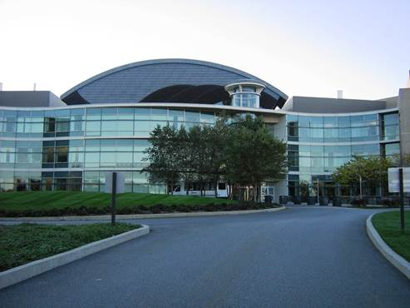  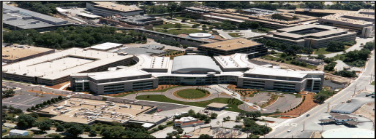  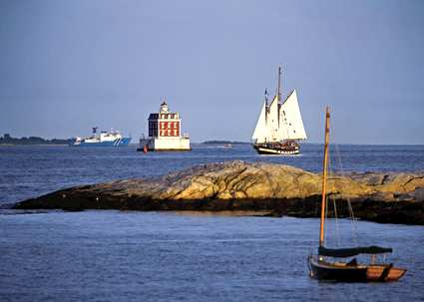  Figure 1 Pfizer, Inc. Groton Campus 220 Building Main Entrance  Figure 2 Aerial View of the Groton Campus  Figure 3 View out on the sound just seconds from the Groton Campus | 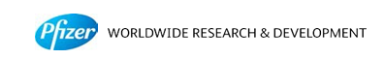  Pfizer, Inc. is pleased to host the 2016 PPAR meeting, the 14th annual gathering of Pharma/PAT practitioners, which will be held this year at the Pfizer, Inc. site in Groton, CT.  This meeting will hold the latest benchmarking and technology-based discussions on PAT. As always, the meeting will provide an informal opportunity for participants to exchange ideas, share experiences, discuss technologies, and to network, meet and greet associates. The setting will be business casual as all the participants discuss their real-life experience with the implementation of PAT tools and solutions in R&D and/or Manufacturing.  Examples of previous topics and kick-off slides are available on the home page of the PPAR: www.patroundtable.org.  Preliminary Schedule
 | Mon, October 24th | Arrival and Reception  6:00 – 9:00 p.m.
 | Tues, October 25th | Meet at Pfizer and discuss PAT topics with practitioners of PAT from various Pharmaceutical companies. Tour the PCMM facility (7:30 a.m. – 5:00 p.m.)  Participate in a group dinner hosted by Pfizer  (6:30 – 10:00 p.m.)
 | Wed, October 26th | Continue further technical discussions (7:30 a.m. – 3:30 p.m.)

Discussion topics

The detailed agenda of the meeting will be forthcoming, and is focused on various aspects of Continuous Manufacturing experiences and forward looking topics:

- Drug Product & API Continuous Manufacturing
- Infrastructure: Data Management/Historians/Automation
- Batch to Continuous Conversion
- Guidance Landscape & Regulatory topics
- Cleaning
- Model Maintenance, Sensor Robustness etc.

Participation at the meeting is limited and a premium is placed on active contributors!

Steering Committee

Steve Doherty Abbvie
Gary McGeorge BMS
Victor Saucedo Genentech
Lorenz Liesum Novartis
Busolo Wabuyele Merck
Joep Timmermans Pfizer
Cenk Undey Amgen
Justin Pritchard Vertex

Dora Kourti ISPE Jim Rydzak GSK
Jeffrey Weber Pfizer

2016 Host

Sonja Sekulic, on behalf of Pfizer. For more information on attending this meeting or its agenda, please contact Sonja.s.sekulic@pfizer.com or Phone: (860-441-6879) or any other member of the steering committee.

Lodging

Pfizer, Inc. has reserved a block of rooms at the Hilton Mystic at a group rate of $125.35 (tax incl.) per night. Meeting participants are responsible for all airfare and lodging associated costs. When making your reservation, please ask for the PPAR rate.

Cancellations

The Steering Committee understands that unanticipated circumstances may require changes to your plans, and respectfully requests that you inform the organizer as soon as possible of any cancellation. Communication in advance of the meeting may facilitate the participation of others.

Registration Form

Please complete this form and e-mail (sonja.s.sekulic@pfizer.com) or phone details to 860.441.6879
Registration deadline is September 30, 2016, or when maximum capacity is reached.
There are no registration fees for PPAR 2016. However, registration is required for on-site access (badges will be provided at the front desk during check-in).
Due to limited space, registration is at the discretion of the Steering Committee.

Name: | Company:
Name on ID badge: | Location:
Phone: | Email:

Lodging
PPAR 2016 will have a block of rooms at the Hilton Mystic at 20 Coogan Blvd Mystic, CT. To make a reservation at the block rate, please contact the Hilton directly at (860) 572-0731 and ask for the PPAR meeting and the $125.35 rate.

Activities

Yes, I will be able to attend the PPAR Roundtable ________

I have reserved a room at the Mystic Hilton Hotel:

Check In: _______________ Check Out: _______________ Number of nights: _____________

Sorry, I cannot make it this year ________

(please indicate your preference)
I will / will not attend :
Group Reception on the evening of Oct. 24th (6:00 – 9:00 pm)
(please indicate your preference)
I will / will not attend:
Group Dinner on the evening of Oct. 25th (6:15 – 9:00 p.m.; Location TBD)

Special Dietary Needs/Other Requirements:

Directions / Transportation

The address of the meeting is:
Pfizer, Inc.
Building 200, Main Campus
284 Shennecossett Road
Groton, CT 06340
Phone (860) 441-4000

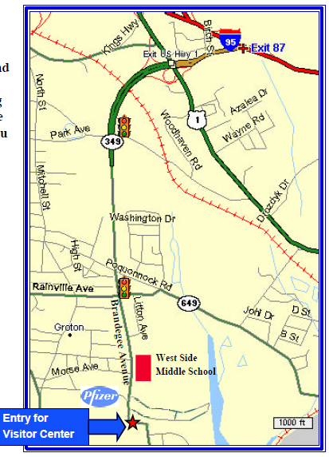

- Proceed South on I-95 to Exit 87 (left hand exit) in Groton (Clarence B. Sharp Memorial Highway or Connecticut Route 349), and proceed to the second traffic light (intersection with Rainville Avenue).
- Go Straight through the second light onto Brandegee Avenue. Pass West Side Middle School on the left and look for the right hand turn off lane into Pfizer.
- Turn Left into the Pfizer entrance at the Visitor Center Building. Do Not pass through the gates.
- Please park in the visitor’s area and check in at the security desk. Once you check in you will be directed to drive to the 220 parking area. You will enter the 220 Building to get to your meeting room in building 200.

Directions to the Mystic Hilton Hotel from Providence T.F. Green Airport (PVD)

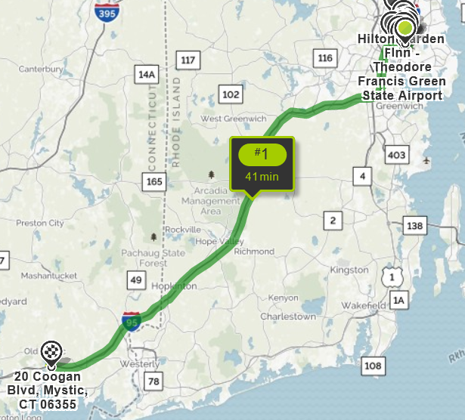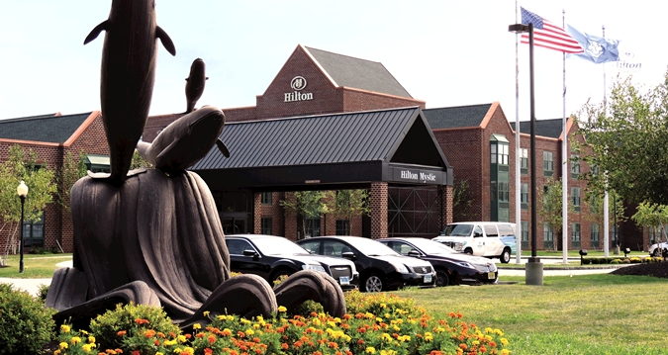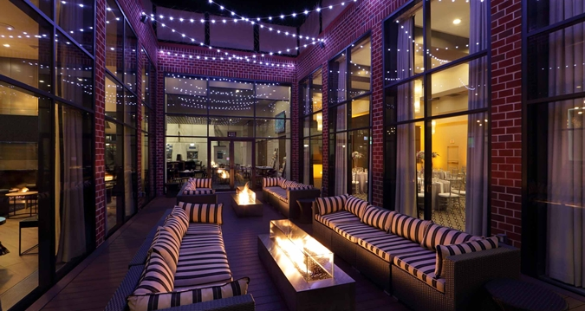
- Proceed South on I-95 toward New York.

- Take Exit 90 in Mystic (Mystic Aquarium/Mystic Seaport CT-27 Exit)

- Turn left onto CT- 27. (Friendly’s will be on your right)

- At second light turn left onto Coogan Blvd.

- Follow to light at corner where Mystic Aquarium is on your left. Hilton Mystic will be on your right.
Meeting objectives

In order to ensure active participation and mutually beneficial discussions for all attendees, the Steering Committee is requesting that attendees please provide a short paragraph regarding each of these questions. The answer of these questions will be used to determine agenda topics, discussion leads and potential areas of break-out sessions.

What two things do you most want to get out of this roundtable discussion?
What two things do you feel you could share during this roundtable discussion?

